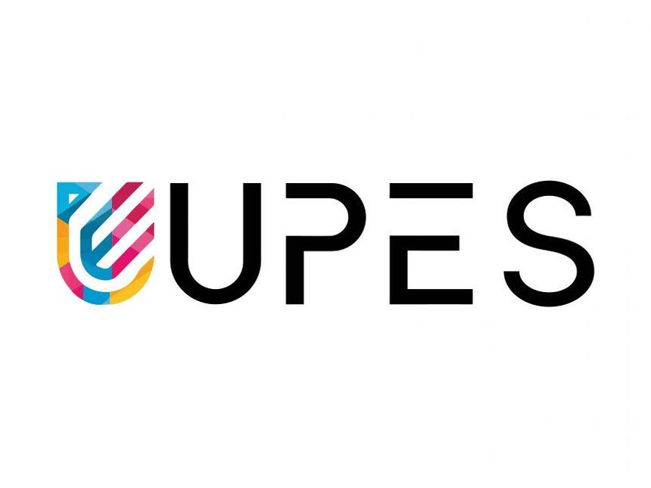

PYTHON PROGRAMMING LAB FILE

Name: Yogesh Dinesh Joshi
Sap ID: 590025632
Batch: 34
Teacher: Sugandha Sharma

Experiment 10

Objective 1 : Create numpy array to find sum of all elements in an array.
Code : 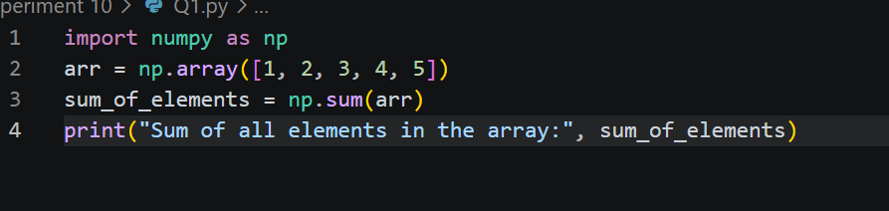
Output : 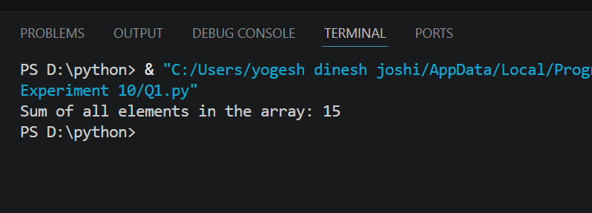

Objective 2 : Create numpy array of (3,3) dimension. Now find sum of all rows & columns individually. Also find 2nd maximum element in the array.
Code : 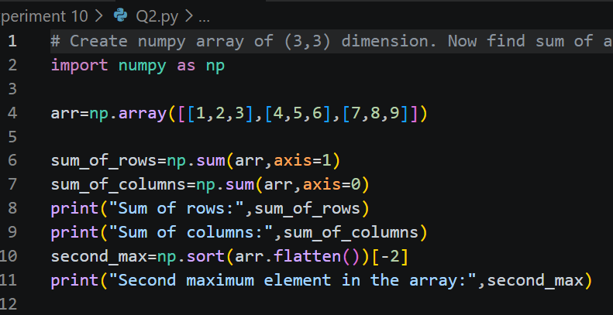
Output : 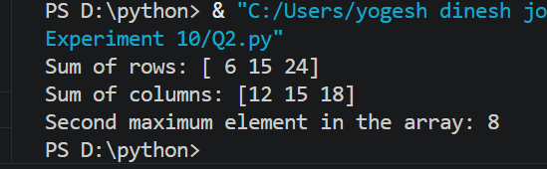

Objective 3 : Perform Matrix multiplication of any 2 n*n matrices.
Code : 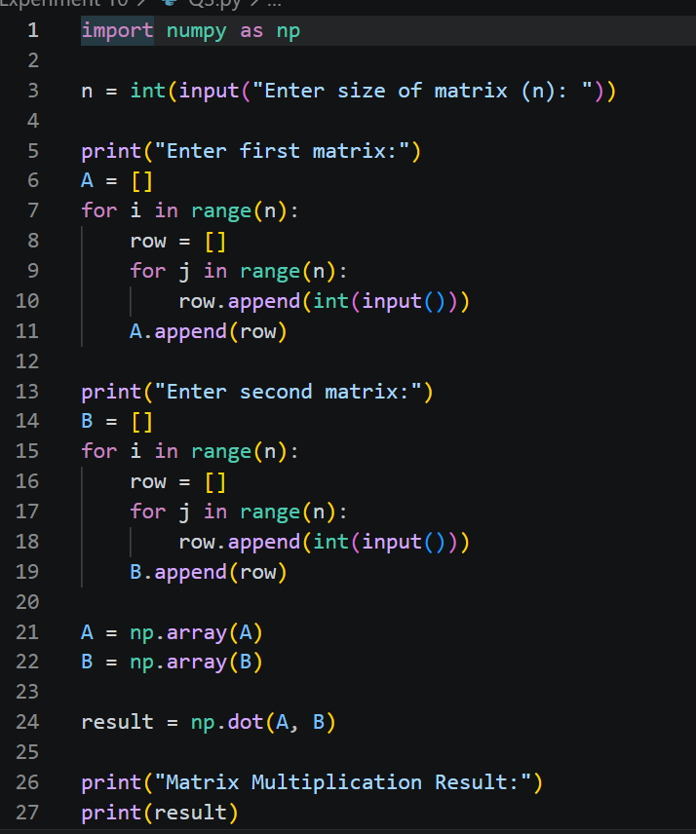
Output : 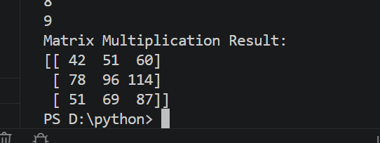
Objective 4 : Write a Pandas program to get the powers of an array values element-wise.
Note: First array elements raised to powers from second array
Sample data: {'X':[78,85,96,80,86], 'Y':[84,94,89,83,86],'Z':[86,97,96,72,83]}
Expected Output:
X Y Z
0 78 84 86
1 85 94 97
2 96 89 96
3 80 83 72
4 86 86 83
Code : 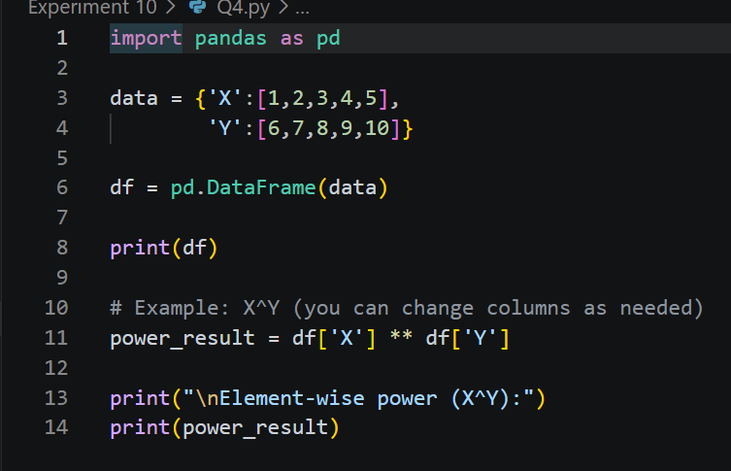
output : 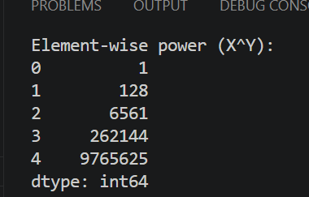

Objective 5 : Write a Pandas program to get the first 3 rows of a given DataFrame.
Code : 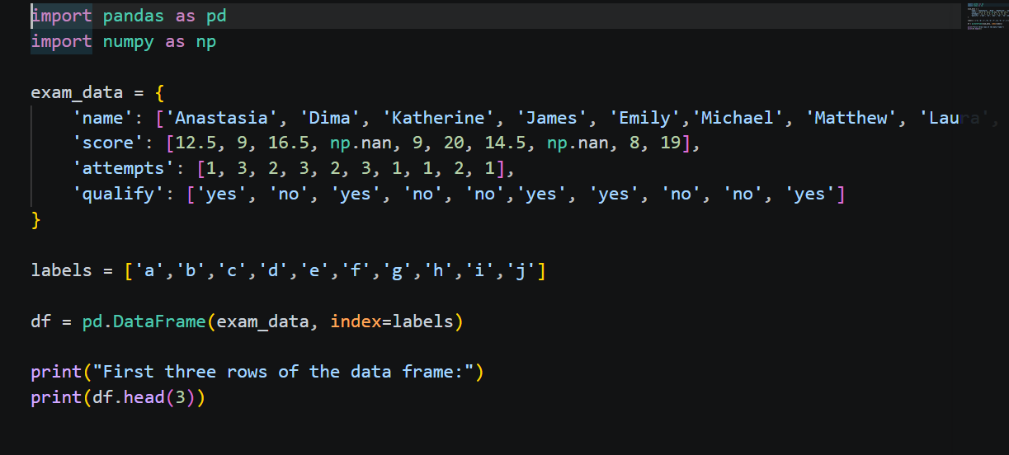
Output : 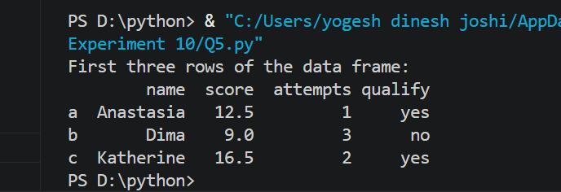

Objective 6: Write a Pandas program to find and replace the missing values in a given DataFrame which do not have any valuable information.
Code : 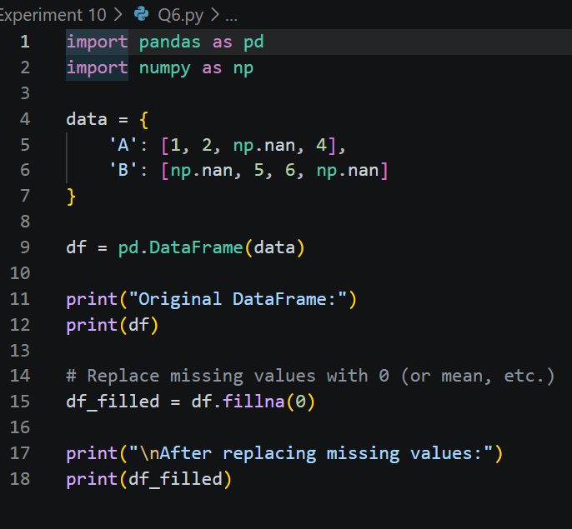
Output : 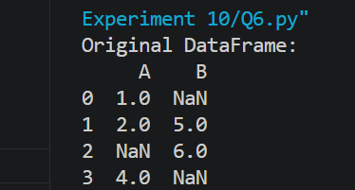
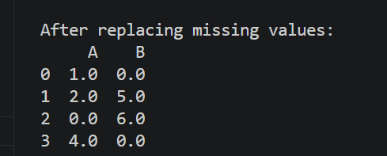

Objective 7 : Create a program to demonstrate different visual forms using Matplotlib.
Code : 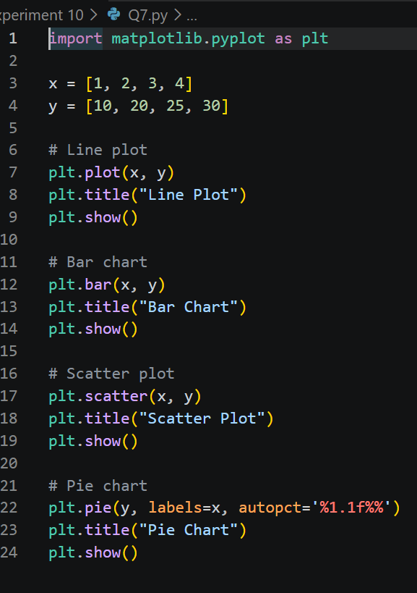
Output : 